Practical 2

Programming Resources

Android Resources: (Color, Theme, String, Drawable, Dimension, Image),

# Defining Color Property.

## Create a new project and go to: ProjectName>App>src>main>res>values>**colors.xml**

1. Defining new color properties in **colors.xml**

Go to

ProjectName->app->res->values->colors.xml

Colors.xml

*<?***xml version="1.0" encoding="utf-8"***?>*

<**resources**>

<**color name="colorPrimary"**>#008577</**color**>

<**color name="colorPrimaryDark"**>#00574B</**color**>

<**color name="colorAccent"**>#D81B60</**color**>

// Define new colors here using hexadecimal color codes.

<**color name="Red"**>#FF0000</**color**>

<**color name="Blue"**>#0000FF</**color**>

<**color name="Pink"**>#FF00FF</**color**>

<**color name="Cyan"**>#00FFFF</**color**>

<**color name="Grey"**>#AABBFF</**color**>

</**resources**>

Add this code in the colors.xml

Default Content

Now go to **activity_main.xml** and type the following code:

* Drag and drop LinearLayout(Vertical) From Layout tab in Palette window
* Drag and drop four TextView from Text tab in palette window
* The default Code of one TextView is as follows

<TextView android:id="@+id/textView"

android:layout_width="match_parent" android:layout_height="56dp" android:text="TextView" />

Now call the colors from the colors.xml as

android:background="@color/Red"

Now the TextView Code looks like

<TextView android:id="@+id/textView"

android:layout_width="match_parent" android:layout_height="56dp" android:text="TextView"

android:background="@color/Red"

Now the final Code of **activity_main.xml is**

*<?*xml version="1.0" encoding="utf-8"*?>*

<androidx.constraintlayout.widget.ConstraintLayout xmlns:android=["http://schemas.android.com/apk/res/android](http://schemas.android.com/apk/res/android)"

xmlns:app=["http://schemas.android.com/apk/res-auto"](http://schemas.android.com/apk/res-auto) xmlns:tools="<http://schemas.android.com/tools>" android:layout_width="match_parent" android:layout_height="match_parent" tools:context=".MainActivity">

<LinearLayout android:layout_width="409dp" android:layout_height="729dp" android:orientation="vertical" tools:layout_editor_absoluteX="1dp" tools:layout_editor_absoluteY="1dp">

<TextView android:id="@+id/textView"

android:layout_width="match_parent" android:layout_height="56dp" android:text="TextView"

android:background="@color/Red"

**S.Y.BSc(C.S) SEM-VI Maharashtra College Android App Development**

Add this line only

/>

<TextView android:id="@+id/textView2"

android:layout_width="match_parent" android:layout_height="52dp" android:text="TextView"

android:background="@color/Grey"

/>

<TextView android:id="@+id/textView3"

android:layout_width="match_parent" android:layout_height="59dp" android:text="TextView"

android:background="@color/Blue"

/>

<TextView android:id="@+id/textView4"

android:layout_width="match_parent" android:layout_height="51dp" android:text="TextView"

android:background="@color/Cyan"

/>

</LinearLayout>

</androidx.constraintlayout.widget.ConstraintLayout>

Add this line only

Add this line only

Add this line only

Output-

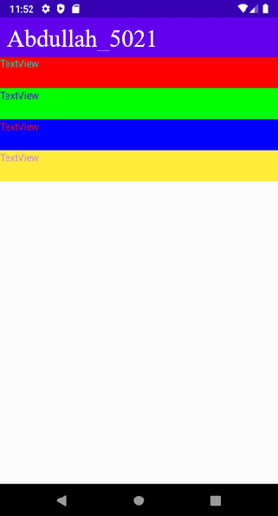

We are done with Colors

# Defining Theme Property.

* + - * Defining new theme properties in **styles.xml**

## Create a new project and go to: ProjectName>App>src>main>res>values>**styles.xml**

styles.xml

<**resources**>

*<!-- Base application theme. -->*

<**style name="AppTheme" parent="Theme.AppCompat.Light.DarkActionBar"**>

*<!-- Customize your theme here. -->*

<**item name="colorPrimary"**>@color/colorPrimary</**item**>

<**item name="colorPrimaryDark"**>@color/colorPrimaryDark</**item**>

<**item name="colorAccent"**>@color/colorAccent</**item**>

<**item name="android:background"**>#000000</**item**>

<**item name="android:textColor"**>#FFFFAA</**item**>

</**style**>

</**resources**>

Add these lines in styles.xml

Output

Output-

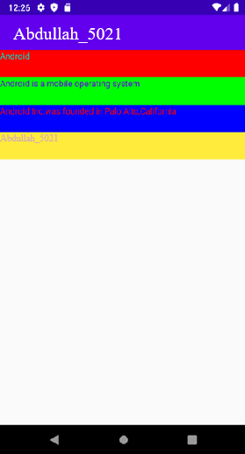

We are done with the styles

# Defining string property

* + - * Defining paragraph and header property in **strings.xml**

## Create a new project and go to: ProjectName>App>src>main>res>values>**strings.xml**

strings.xml

<resources>

<**string name="app_name"**>Prof. Shahid Ansari</**string**>

<**string name="Heading"**>Programming Resources</**string**>

<string name="Description">

Android is a mobile operating system developed by Google.

It is based on a modified version of the Linux kernel and other open source software, and is designed primarily for touch screen mobile devices such as smart phones and tablets

</**string**>

</**resources**>

Now go to **activity_main.xml** and type the following code

<**TextView android:id="@+id/textView"**

**android:layout_width="match_parent" android:layout_height="56dp" android:background="@color/Red"**

**android:text="@string/Heading" android:textSize="24sp"** />

<**TextView android:id="@+id/textView2"**

**android:layout_width="match_parent" android:layout_height="wrap_content" android:background="@color/Grey"**

**android:text="@string/Description" android:textSize="24sp"** />

Change this attribute

Change this attribute

Output-



1. **Adding images and dimensions**

## Adding Images to Application created

* + - * For adding a new image files, do the following:
      * ProjectName>App>src>main>res>drawable>Right-click and paste the images that are copied

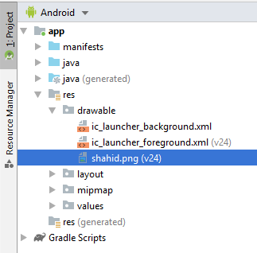

* + - * Add a new **dim.xml** file and write the following code in dimens.xml

*<?*xml version="1.0" encoding="utf-8" *?>*

<resources>

<**dimen name="textview_height"**>35dp</**dimen**>

<**dimen name="textview_width"**>150dp</**dimen**>

<**dimen name="font_size"**>26sp</**dimen**>

</**resources**>

Now go to **activity_main.xml** and type the following code:

*<?***xml version="1.0" encoding="utf-8"***?>*

<**androidx.constraintlayout.widget.ConstraintLayout xmlns:android=**[**"http://schemas.android.com/apk/res/android**](http://schemas.android.com/apk/res/android)**"**

**xmlns:app=**[**"http://schemas.android.com/apk/res-auto"**](http://schemas.android.com/apk/res-auto) **xmlns:tools="**[**http://schemas.android.com/tools**](http://schemas.android.com/tools)**" android:layout_width="match_parent" android:layout_height="match_parent" tools:context=".MainActivity"**>

<**LinearLayout android:layout_width="409dp" android:layout_height="729dp" android:orientation="vertical" tools:layout_editor_absoluteX="1dp" tools:layout_editor_absoluteY="1dp"**>

<**ImageView android:id="@+id/imageView" android:layout_width="match_parent" android:layout_height="wrap_content"**

</**LinearLayout**>

</**androidx.constraintlayout.widget.ConstraintLayout**>

**app:srcCompat="@drawable/shahid"** />

Output-

